CPS470: Computer Networks and Security

Written Homework 5
Total Points: 100

Note: In all written assignments, please show as much of your work as you can. Even if you get a wrong answer, you can get partial credit if you show your work. If you make a mistake, it will also help the grader show you where you made a mistake. You can either type your answers in the solution area and submit the file directly on Isidore or hand-write your answers and get a scanned version of it to submit on Isidore. If you find the default space is not sufficient for you to type/handwrite your answers, please feel free to enlarge the space as needed. Please make sure your handwriting is clear and understandable. If the grader or I cannot understand your handwriting, you get zero for your solutions.

Problem 1: Dijkstra’s Link State Routing. Consider the 6-node network shown below, with the given link costs. Using Dijkstra's algorithm, find the least cost path from source node u to all other destinations. Show your work in tabular format, as in the network control plane slides.
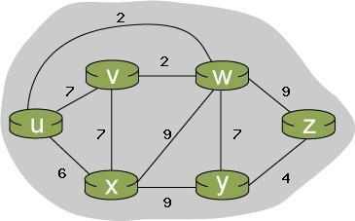

Solution:

I followed the same table we did in class and instead of highlighted where it chose to travel to next as seen below.
Step | N’ | v | w | x | y | z
v | u | 7,u | 2,u | 6,u | ∞ | ∞
w | uw | 4,w |  | 6,u | 9,w | 11,w
x | uwv |  |  | 6,u | 9,w | 11,w
y | uwvx |  |  |  | 9,w | 11,w
z | uwvxy |  |  |  |  | 11,w

Destination | Path | Cost
v | u → v | 6
w | u → w | 2
x | u → w → x | 4
y | u → w → y | 9
z | u → w → z | 11

v and w are direct paths from u while x, y, and z are indirect paths from u.

Problem 2: Distance Vector Routing.

Consider the network fragment shown below. x has only two attached neighbors, w and y . w has a minimum-cost path to destination u (not shown) of 5, and y has a minimum-cost path to u of 6. The complete paths from w and y to u (and between w and y ) are not shown. All link costs in the network have strictly positive integer values.
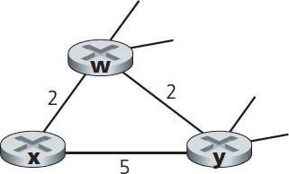

- Give x ’s distance vector for destinations w, y, and u .
- Give a link-cost change for either c (x,w ) or c (x,y ) such that x will inform its neighbors of a new minimum-cost path to u as a result of executing the distance-vector algorithm.
- Give a link-cost change for either c (x,w ) or c (x,y ) such that x will not inform its neighbors of a new minimum-cost path to u as a result of executing the distance-vector algorithm.

Solution:

c(x, w) = 2
c(x, y) = 5
c(w, y) = 2

Dw(u) = 5
Dy(u) = 6

a:
Dx(w) = min ( c(x, w) + Dw(w), c(x,y) + Dy(w) )
= min ( 2, 7 ) = 2

Dx(y) = min ( c(x, y) + Dy(y), c(x,w) + Dw(y) )
= min ( 5 , 4 ) = 4

Dx(u) = min ( c(x, w) + Dw(u), c(x,y) + Dy(u) )
= min ( 7, 11 ) = 7

b:
Change c(x,w) to 7 such that Dx(u) = min (12, 11) = 11

c:
Change c(x,y) to 6 such that Dx(u) = min (7, 12) = 7

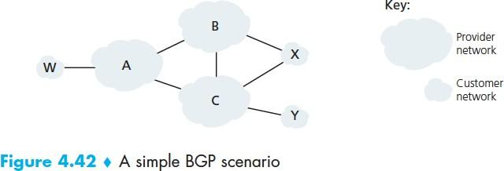
Problem 3: BGP and path advertisement.

Figure 4.42 is shown to the right.

Consider the path information that reaches stub networks W,
X, and Y. Based on the information available at W and X, what are their respective views of the network topology? [Hint: you need to think about
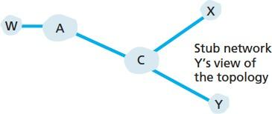
which networks pass on which path information to neighboring networks]. Justify your answer. The topology view at Y is shown to the right (lower), so you really only need to answer this question for W and X.

Solution:

Topology for W
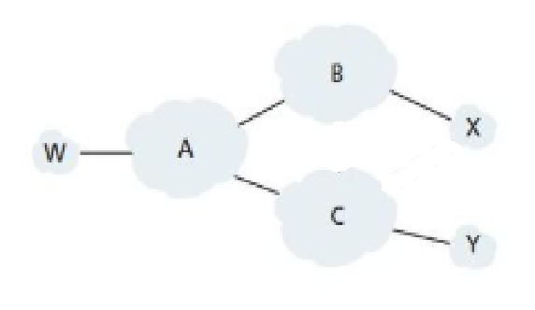
W will always go to A, but then it can do a few things for the path to reach x and y. For example, the only way to reach Y from here correctly is to go W > A > C > Y, but to reach X you can do 2 different things, W > A > B > X or W > A > C > X. I chose B since it comes first on the alphabet.

Topology for X
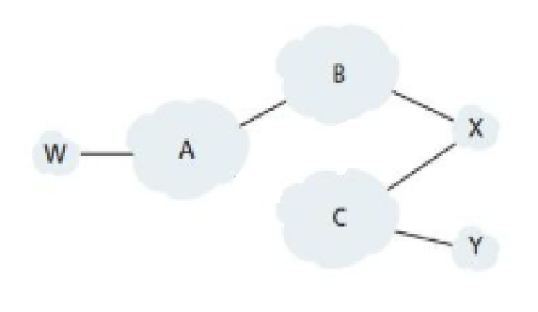

X Can go to B or C from the start, to reach W you can do 2 different things, X > B > A > W or
X > C > A > W. I chose for it to take B since it is sooner on the alphabet. To Reach Y the shortest route is X > C > Y

